Rodrigo Becerril Ferreyra
CECS 440 Section 02
Lab 2
01 October 2021
Part 1
Before I get started with this Part, I would like to post the expected results.
Problem 1:
The result of this code is
#include <stdio.h>

int main(void)
{
int var1[4] = {7, 18, 11, 3};
int var2[4] = {12, 14, 7, 18};
int result[4] = {0};

for(int i = 0; i < 4; i++)
{
result[i] = var1[i] - var2[i];
printf("%d ", result[i]);
}

return 0;
}
Problem 2:
-5 4 4 -15
The result of this code is
#include <stdio.h>

int main(void)
{
short var1[4] = {7, 18, 11, 3};
short var2[4] = {12, 14, 7, 18};
short result[4] = {0};

for(int i = 0; i < 4; i++)
{
result[i] = var1[i] - var2[i];
printf("%d ", result[i]);
}

return 0;
}
Problem 3:
-5 4 4 15
The result of this code is:
#include <stdio.h>

int main(void)
{
unsigned short var1[4] = {7, 18, 11, 3};
unsigned short var2[4] = {12, 14, 7, 18};
unsigned short result[4] = {0};

for(int i = 0; i < 4; i++)
{
result[i] = var1[i] - var2[i];
printf("%d ", result[i]);
}

return 0;
}
Problem 1 Responses:
65531 4 4 65521
There is a lot of data in Problem 1. There are three arrays, each with four elements each, which means I needed to use .data to create sequential words in memory. The address of var1 is stored in $s0, the address of var2 is stored in $s1, and the address of result is stored in $s2. The temp variables are used for many different purposes. $t0 is used to load the initial values into the data, as well as to keep track of the iteration. $t1 is used to align address values in order to access words; this means that it is $t0 shifted to the left two times. $t1 can also be the check that is used to see whether the program should loop again or not. $t2, $t3, and $t4 hold the address of var1[i], var2[i], and result[i], respectively, but only after they have been aligned with memory; in practice, this means that they are always $s0, $s1, and $s2 after they have been added to $t1. $t5, $t6, and $t7 all hold the values of var1[i], var2[i], and result[i], respectively; the last set of three registers only held the addresses of those values.
The three arrays are stored in memory sequentially. These are stored as follows:
The address 0x10010000 stores the address of the first element in array var1. This array has a total size of four words (which is equal to 16 bytes or 128 bits), with each element taking up one 32-bit word (the size of an int in a standard C compiler). Since MIPS is a big-endinan ISA, the values are added in from the most significant word to the least significant word; these are 0x7, 0x12, 0xb, and 0x3. var2 has a similar arrangement, with its contents allocated in four words starting from 0x10010010, which is 16 bytes higher than the starting address of var1. The last array is only initialized after the loop begins; this is the result array, which has a starting address of 0x10010020 (16 bytes higher than var2).
User data segment [10000000]..[10040000]
[10000000]..[1000ffff] 00000000
[10010000] 00000007 00000012 0000000b 00000003 . . . . . . . . . . . . . . . .
[10010010] 0000000c 0000000e 00000007 00000012 . . . . . . . . . . . . . . . .
[10010020] fffffffb 00000004 00000004 fffffff1 . . . . . . . . . . . . . . . .
[10010030]..[1003ffff] 00000000
Figure 1: The final output for Part 1 Problem 1.
The final values located in the result array are 0xfffffffb, 0x00000004, 0x00000004, and 0xfffffff1. Translated into signed decimal representation, these values are -5, 4, 4, and -15, which is the expected value.
Below is the final code for Part1int.asm (also included in the submission):
# Project name: Lab 2
# Author : Rodrigo Becerril Ferreyra
# Date written: 30 September 2021

.data

var1: .word 0, 0, 0, 0
var2: .word 0, 0, 0, 0
result: .word 0, 0, 0, 0

.text
.globl main

main:

# int var1[4] = {7, 18, 11, 3};
la $s0, var1

addi $t0, $zero, 7
sw $t0, 0($s0)
addi $t0, $zero, 18
sw $t0, 16($s0)
addi $t0, $zero, 11
sw $t0, 32($s0)
addi $t0, $zero, 3
sw $t0, 64($s0)

# int var2[4] = {12, 14, 7, 18};
la $s1, var2

addi $t0, $zero, 12
sw $t0, 0($s1)
addi $t0, $zero, 14
sw $t0, 4($s1)
addi $t0, $zero, 7
sw $t0, 8($s1)
addi $t0, $zero, 18
sw $t0, 12($s1)

# int result
la $s2, result

# from this point on:
# t0 = i
# t1 can be (i * 4) or can be (i < 4)
# t2 = address of var1[i * 4]
# t3 = address of var2[i * 4]
# t4 = address of var3[i * 4]
# t5 = value of *t2
# t6 = value of *t3
# t7 = t5 + t6

# s0 = address of var1
# s1 = address of var2
# s2 = address of result

# int i = 0
add $t0, $zero, $zero

loop:
# loop body

sll $t1, $t0, 2 # t1 = i * 4

add $t2, $t1, $s0 # addr of var1[i * 4]
lw $t5, 0($t2)

add $t3, $t1, $s1 # addr of var2[i * 4]
lw $t6, 0($t3)

add $t4, $t1, $s2 # addr of result[i * 4]

sub $t7, $t5, $t6 # result[i*4] = var1[i*4] - var2[i*4];
sw $t7, 0($t4)

addi $t0, $t0, 1 # i = i + 1

slti $t1, $t0, 4 # 1 if i < 4
bne $zero, $t1, loop # branch if (i < 4) is false

# exit
addi $v0, $zero, 10
syscall
Figure 2: Code for Part 1Problem 1.
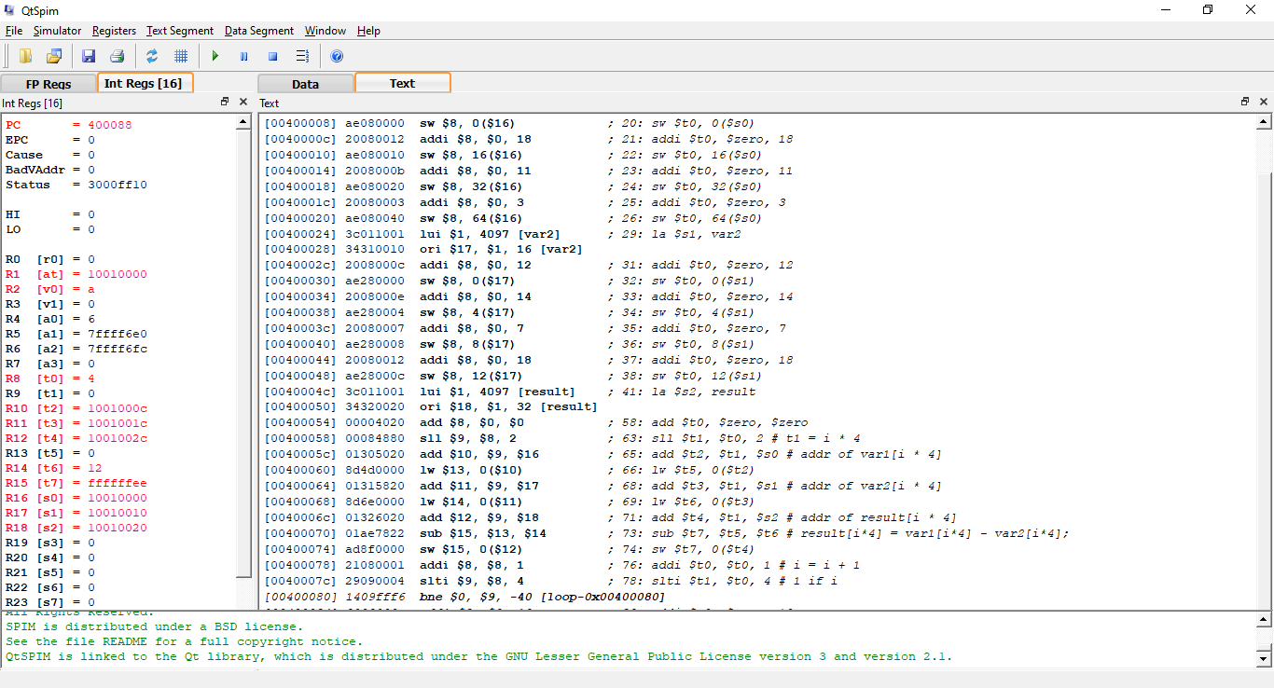Figure 3: Part 1 Problem 1 running on QtSpim.
Problem 2 Responses:
The only difference between Problem 1 and Problem 2 is that Problem 2 works with half-words instead of words (meaning each value is only 16 bits wide instead of 32). The differences in the program are as follows:
- The commands lh and sh are used instead of lw and sw.
- Loads and stores must be aligned to two bytes instead of four (since a half-word is two bytes long).
The same registers used for Problem 1 are used in Problem 2, and for the same purposes.
The following is the memory addresses and values for the three arrays.
The total amount of data here is cut in half because the data size is half of what it was in Problem 1. The same values are present here, even if it is in a different format. The first two words in 0x10010000 are the four values in val1: 7, 18, 11, and 3. The order goes from lower 16 bits to upper 16 bits, then from small address to large address. val2 starts from address 0x10010008, and result is stored at 0x10010010. Reading the values off the address like last time, the results are 0xfffb, 0x0004, 0x0004, and 0xfff1; these are the same values achieved in Problem 1.
User data segment [10000000]..[10040000]
[10000000]..[1000ffff] 00000000
[10010000] 00120007 0003000b 000e000c 00120007 . . . . . . . . . . . . . . . .
[10010010] 0004fffb fff10004 00000000 00000000 . . . . . . . . . . . . . . . .
[10010020]..[1003ffff] 00000000
Below is the final Part1hword.asm program.
# Project name: Lab 2
# Author : Rodrigo Becerril Ferreyra
# Date written: 30 September 2021

.data

var1: .half 0, 0, 0, 0
var2: .half 0, 0, 0, 0
result: .half 0, 0, 0, 0

.text
.globl main

main:

# int var1[4] = {7, 18, 11, 3};
la $s0, var1

addi $t0, $zero, 7
sh $t0, 0($s0)
addi $t0, $zero, 18
sh $t0, 2($s0)
addi $t0, $zero, 11
sh $t0, 4($s0)
addi $t0, $zero, 3
sh $t0, 6($s0)

# int var2[4] = {12, 14, 7, 18};
la $s1, var2

addi $t0, $zero, 12
sh $t0, 0($s1)
addi $t0, $zero, 14
sh $t0, 2($s1)
addi $t0, $zero, 7
sh $t0, 4($s1)
addi $t0, $zero, 18
sh $t0, 6($s1)

# int result
la $s2, result

# from this point on:
# t0 = i
# t1 can be (i * 2) or can be (i < 4)
# t2 = address of var1[i * 2]
# t3 = address of var2[i * 2]
# t4 = address of var3[i * 2]
# t5 = value of *t2
# t6 = value of *t3
# t7 = t5 + t6

# s0 = address of var1
# s1 = address of var2
# s2 = address of result

# int i = 0
add $t0, $zero, $zero

loop:
# loop body

sll $t1, $t0, 1 # t1 = i * 2

add $t2, $t1, $s0 # addr of var1[i * 2]
lh $t5, 0($t2)

add $t3, $t1, $s1 # addr of var2[i * 2]
lh $t6, 0($t3)

add $t4, $t1, $s2 # addr of result[i * 2]

sub $t7, $t5, $t6 # result[i*2] = var1[i*2] - var2[i*2];

sh $t7, 0($t4)

addi $t0, $t0, 1 # i = i + 1

slti $t1, $t0, 4 # 1 if i < 4
bne $zero, $t1, loop # branch if (i < 4) is false

# exit
addi $v0, $zero, 10
syscall
Figure 4: The final program for Part 1 Problem 2.
Problem 3 Responses:
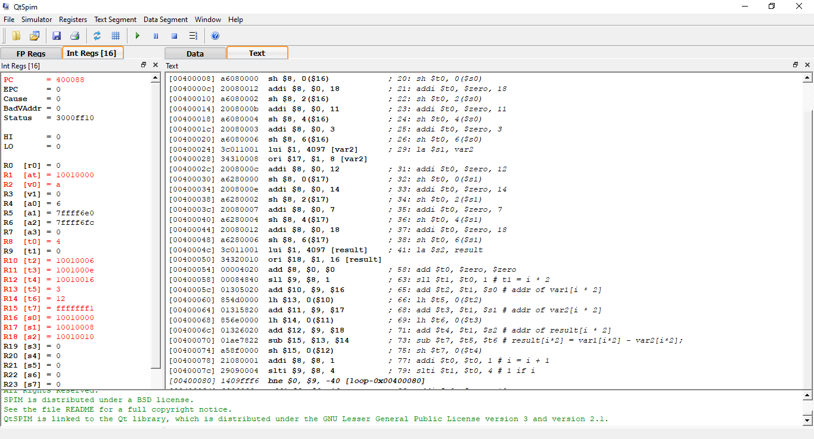Figure 5: Part 1 Problem 2 running on QtSpim.
For Problem 3, I took Problem 2 and replaced all the add, subtract, and load commands with their unsigned variants.
The variable registers are the same as in the previous Problems.
The array locations and format are the same as in Problem 2.
The resulting memory values are presented below.
As you can see, this is actually the same memory output as Problem 2. This is because there is no difference between the add and subtract instructions compared to their unsigned variants. The loads don’t affect anything either; and there is no signed store instruction.
User data segment [10000000]..[10040000]
[10000000]..[1000ffff] 00000000
[10010000] 00120007 0003000b 000e000c 00120007 . . . . . . . . . . . . . . . .
[10010010] 0004fffb fff10004 00000000 00000000 . . . . . . . . . . . . . . . .
[10010020]..[1003ffff] 00000000
Below is the code for Part1uhword.asm.
# Project name: Lab 2
# Author : Rodrigo Becerril Ferreyra
# Date written: 30 September 2021

.data

var1: .half 0, 0, 0, 0
var2: .half 0, 0, 0, 0
result: .half 0, 0, 0, 0

.text
.globl main

main:

# int var1[4] = {7, 18, 11, 3};
la $s0, var1

addiu $t0, $zero, 7
sh $t0, 0($s0)
addiu $t0, $zero, 18
sh $t0, 2($s0)
addiu $t0, $zero, 11
sh $t0, 4($s0)
addiu $t0, $zero, 3
sh $t0, 6($s0)

# int var2[4] = {12, 14, 7, 18};
la $s1, var2

addiu $t0, $zero, 12
sh $t0, 0($s1)
addiu $t0, $zero, 14
sh $t0, 2($s1)
addiu $t0, $zero, 7
sh $t0, 4($s1)
addiu $t0, $zero, 18
sh $t0, 6($s1)

# int result
la $s2, result

# from this point on:
# t0 = i
# t1 can be (i * 2) or can be (i < 4)
# t2 = address of var1[i * 2]
# t3 = address of var2[i * 2]
# t4 = address of var3[i * 2]
# t5 = value of *t2
# t6 = value of *t3
# t7 = t5 + t6

# s0 = address of var1
# s1 = address of var2
# s2 = address of result

# int i = 0
add $t0, $zero, $zero

loop:
# loop body

sll $t1, $t0, 1 # t1 = i * 2

add $t2, $t1, $s0 # addr of var1[i * 2]
lhu $t5, 0($t2)

add $t3, $t1, $s1 # addr of var2[i * 2]
lhu $t6, 0($t3)

add $t4, $t1, $s2 # addr of result[i * 2]

subu $t7, $t5, $t6 # result[i*2] = var1[i*2] - var2[i*2];

sh $t7, 0($t4)

addi $t0, $t0, 1 # i = i + 1

slti $t1, $t0, 4 # 1 if i < 4
bne $zero, $t1, loop # branch if (i < 4) is false

# exit
addi $v0, $zero, 10
syscall
Figure 6: Code for Part 1 Problem 3.
Part 2
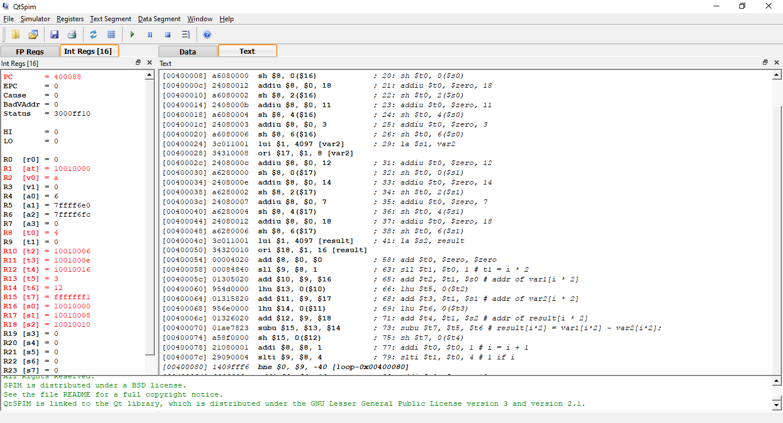Figure 7: Part 1 Problem 3 running on QtSpim.
Problem 1
This problem was a simple implementation of a function. It is important to note that nothing needed to be put on the stack, because the only registers that were modified were $t0, $a0, and $a1, and the function called was a leaf function—that is, it did not call any other function. Technically, if I needed to, I could copy the arguments from the a registers to temporary ones if I wanted to avoid moving argument register values around, but I saw no need for doing so, and it would only add more instructions to the program.
It is worth noting that the program works as intended; i.e., it returns the difference of the highest and lowest argument.
# Project name: Lab 2
# Author : Rodrigo Becerril Ferreyra
# Date written: 30 September 2021

.text
.globl main

main:

# var1 = s0
# var2 = s1
# result = s2

# var1 = 30
addi $s0, $zero, 30

# var2 = 210
addi $s1, $zero, 210

# function call and usage of return value
add $a0, $zero, $s0
add $a1, $zero, $s1
jal distance
add $s2, $zero, $v0

# exit
addi $v0, $zero, 10
syscall

distance:
# a0 = a, a1 = b

# if b > a then swap
slt $t0, $a0, $a1 # 1 if a < b, 0 if a >= b
beq $t0, $zero, skipswap # skip if 0

add $t0, $zero, $a0
add $a0, $zero, $a1
add $a1, $zero, $t0

skipswap: sub $v0, $a0, $a1
jr $ra
Figure 8: The program for Part 2 Problem 1.
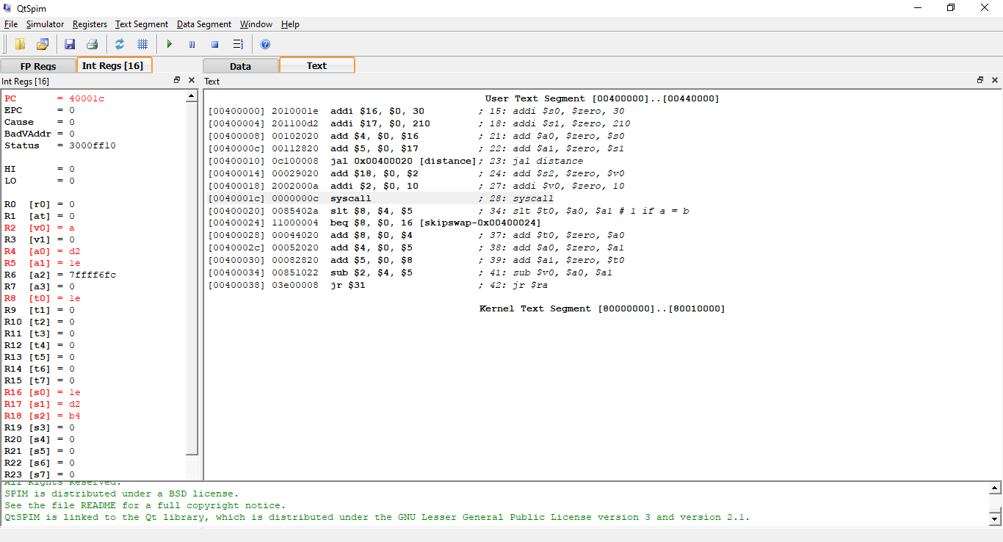Figure 9: Part 2 Problem 1 running on QtSpim.
Problem 2
This problem was a bit more difficult to implement, since one function calls another. In this case, I had to push the return address of the first function to the stack (because the command jal overwrites it), then pop it when the second function returned control to the first. It is worth noting that this program works as intended as well, tested using different values. Also, nothing else needed to be pushed to the stack. The swap function given does not swap because the program does not use pointers. If I were to program like a compiler would, I would distance’s arguments to the stack, place swap’s arguments in the argument registers, call the function, copy the saved arguments from the stack, and pop them. This would result in nothing happening, however, and perhaps distance returning a negative number, which is behavior we don’t want in this program.
# Project name: Lab 2
# Author : Rodrigo Becerril Ferreyra
# Date written: 30 September 2021

.text
.globl main

main:

# var1 = s0
# var2 = s1
# result = s2

# var1 = 30
addi $s0, $zero, 30

# var2 = 210
addi $s1, $zero, 210

# function call and usage of return value
add $a0, $zero, $s0
add $a1, $zero, $s1
jal distance
add $s2, $zero, $v0

# exit
addi $v0, $zero, 10
syscall

distance:
# a0 = a, a1 = b

# if b > a then swap
slt $t0, $a0, $a1 # 1 if a < b, 0 if a >= b
beq $t0, $zero, skipswap # skip if 0

# place $ra on the stack
sub $sp, $sp, 4
sw $ra, 0($sp)

# function call
jal swap

# pop $ra from the stack
lw $ra, 0($sp)
add $sp, $sp, 4

skipswap: sub $v0, $a0, $a1
jr $ra

swap:
# a0 = a, a1 = b
# No need to use the stack here
# If I did, then the values themselves would not change

# swap body
add $t0, $zero, $a0
add $a0, $zero, $a1
add $a1, $zero, $t0

# return
jr $ra
Figure 10: Code for Part 2 Problem 2.
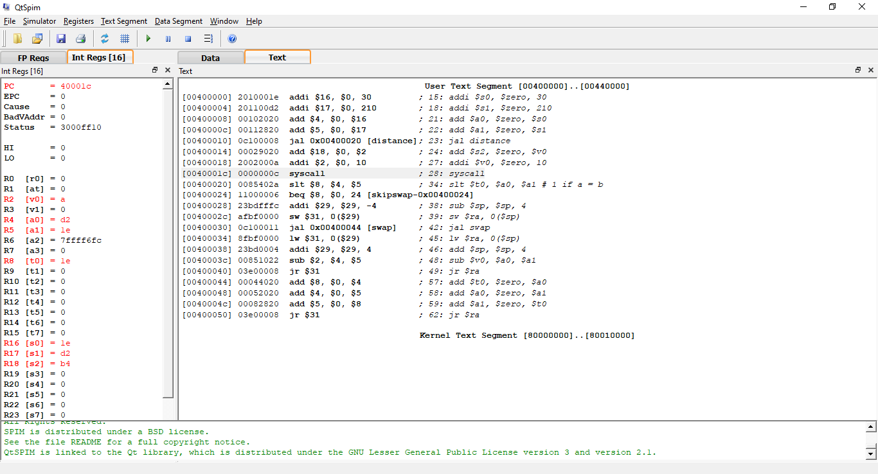Figure 11: QtSpim running Part 2 Problem 2.

